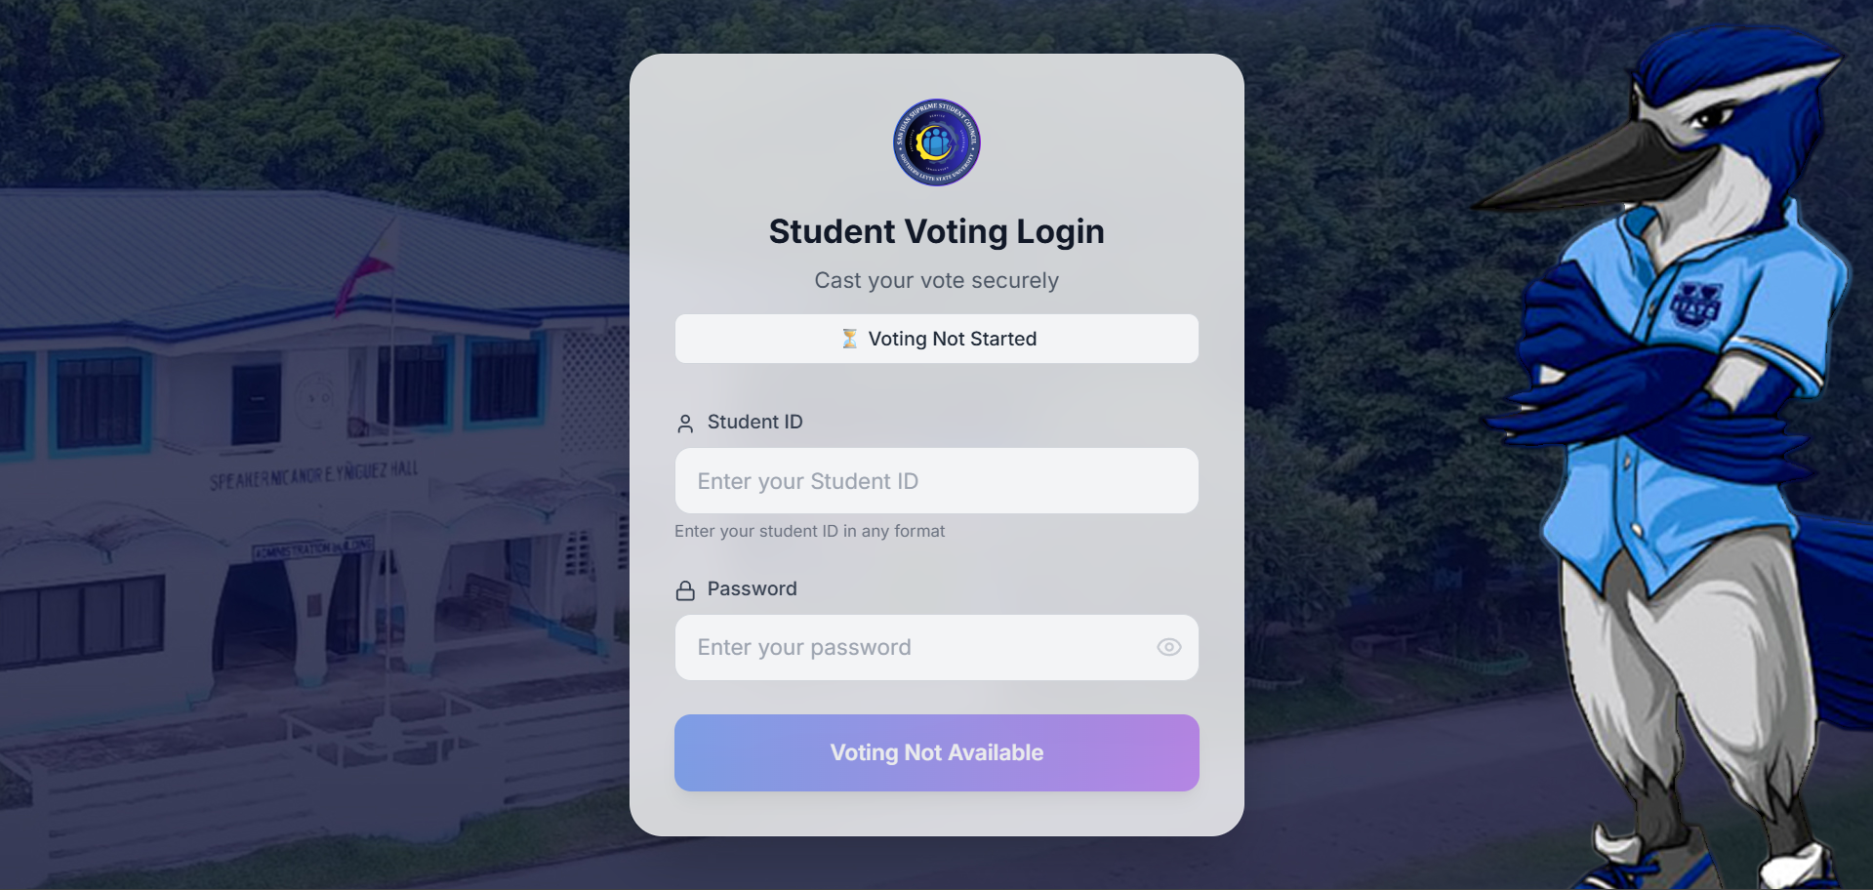

**Student Voting Login Form (Status: Voting Not Started):**

**Poll Controls from Super Admin Dashboard (Status Voting Not Started or Current Status Not Started) Poll Controls is integrated to the Student Voting Login Form:**

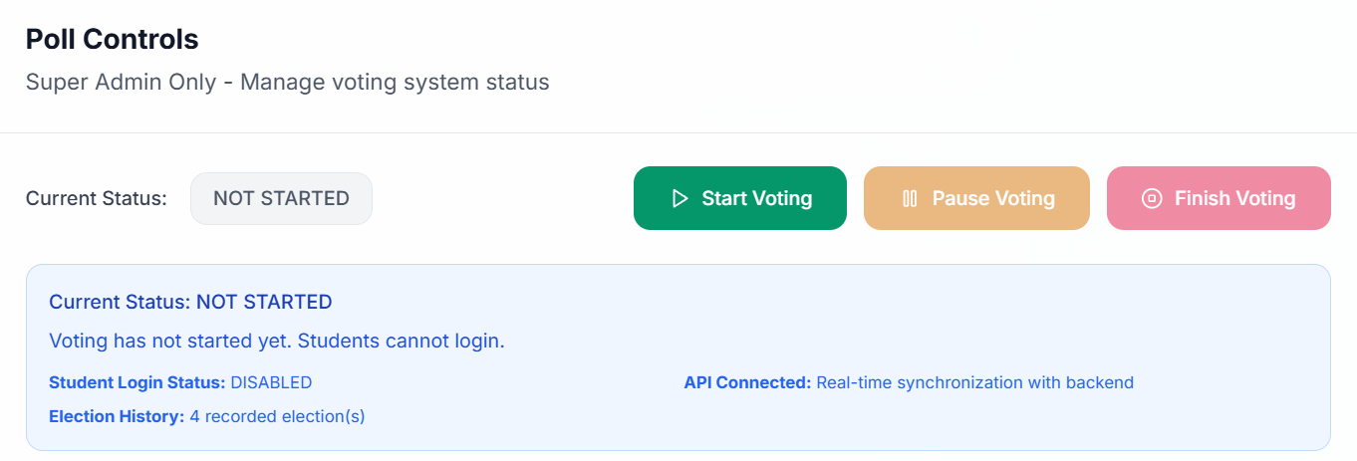

**Student Voting Login Form (Status: Voting Active):**

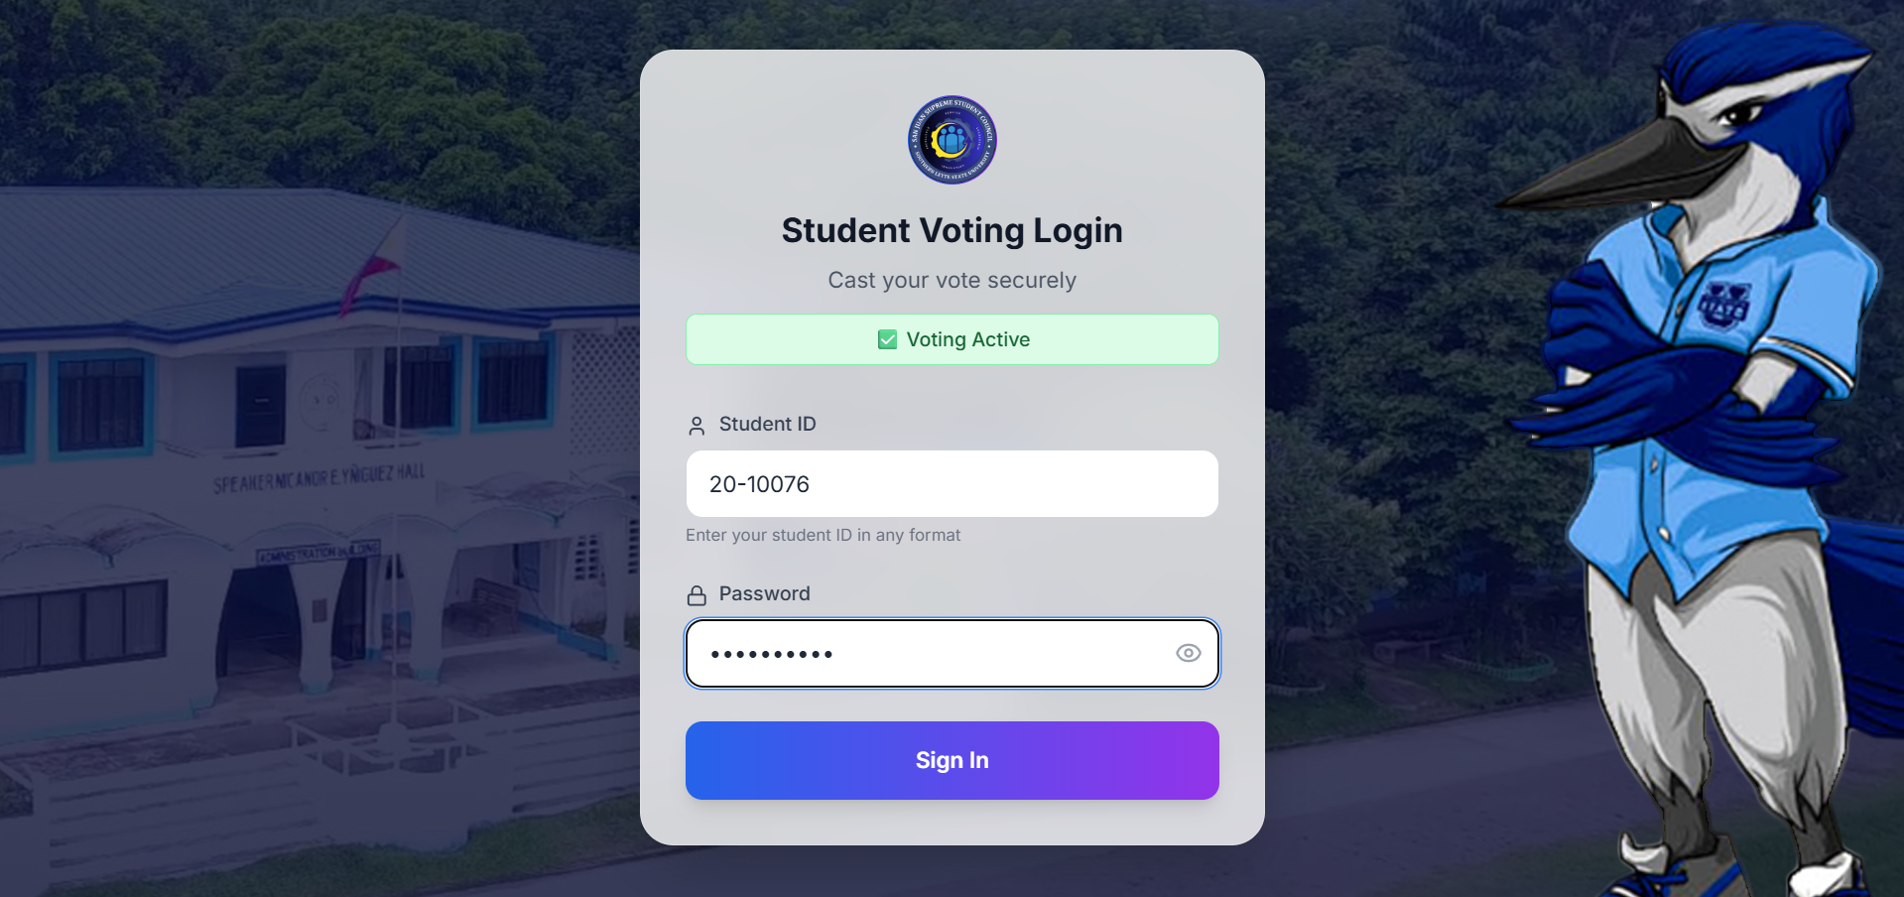

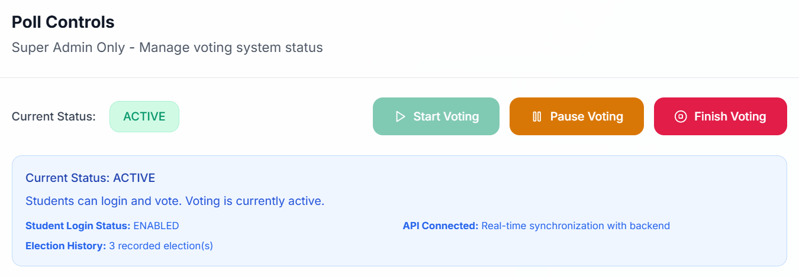

**Poll Controls from Super Admin Dashboard (Status: Voting Active or Current Status: ACTIVE) Poll Controls is integrated to the Student Voting Login Form:**

**Confirmation Modal:**

**Cast Vote Form (if Voter Logged In):**

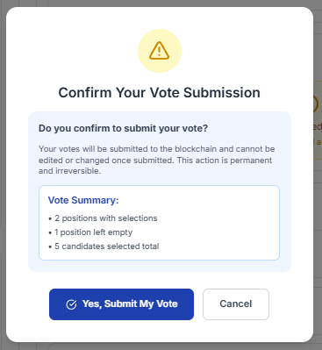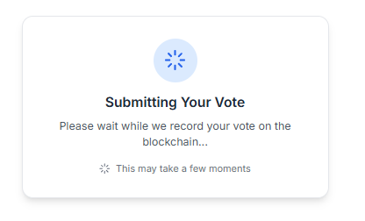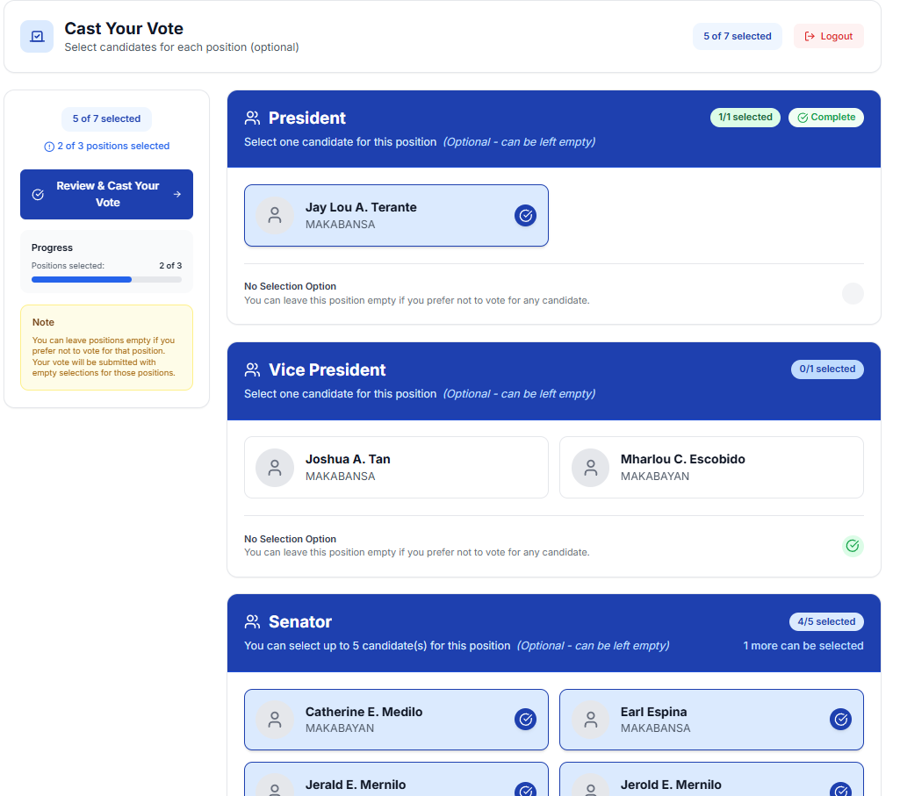

**Submission Process Modal:**

**Transaction Receipt Modal:**

**Review Vote Form (if voter Click from Cast Vote Form the Review & Cast Your Vote Button):**

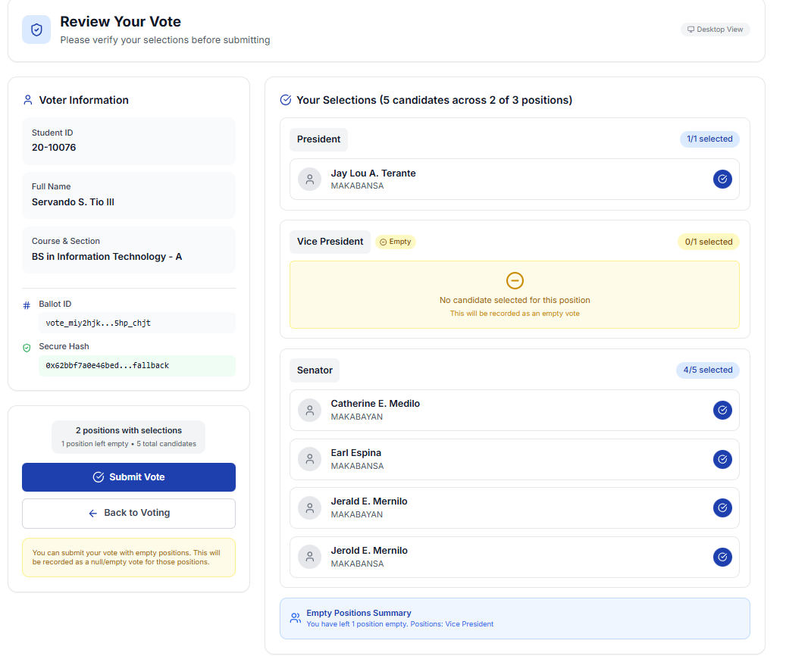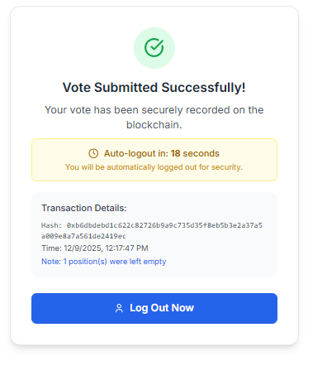

**Error /Already Voted Modal (**If Voter Accidently Refreshed the Transaction Receipt and Submit a Vote Again It Will Check the Voter Status if Voted this shows):

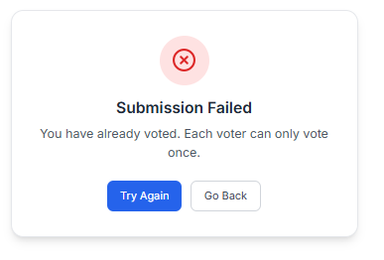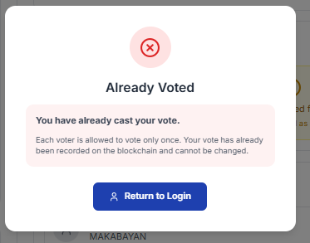

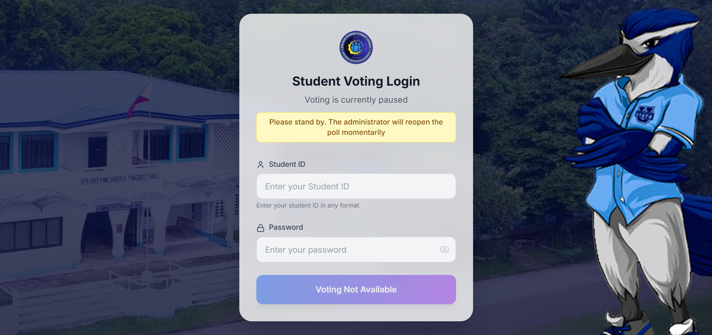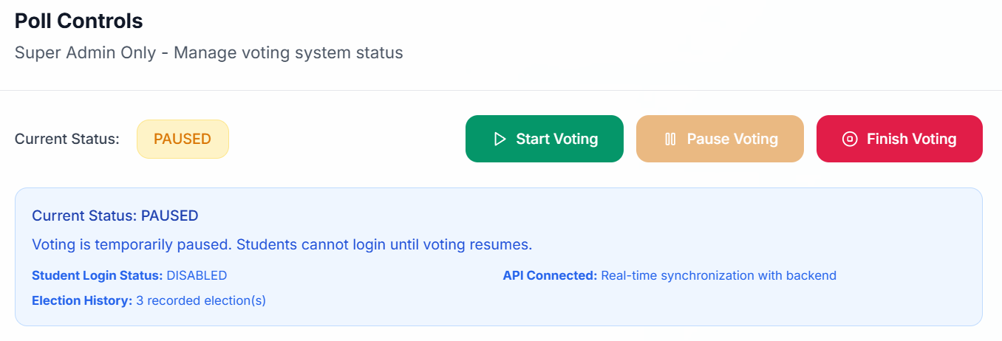

**Student Voting Login Form (Status: Pause):**

**Poll Controls from Super Admin Dashboard (Status: Voting is currently paused or Current Status: PAUSED) Poll Controls is integrated to the Student Voting Login Form:**

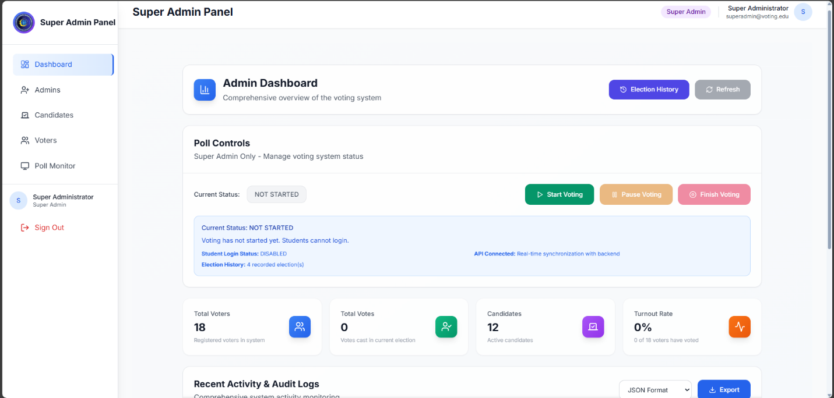**Super Admin Panel (Super Admin Logged In) Dashboard:**

**Election History Modal (if Election History Button is Pressed):**

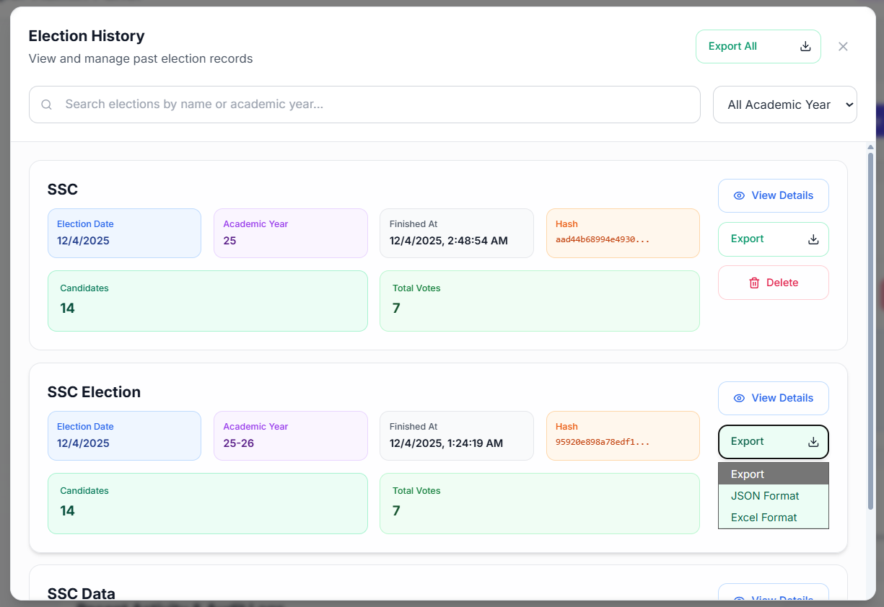

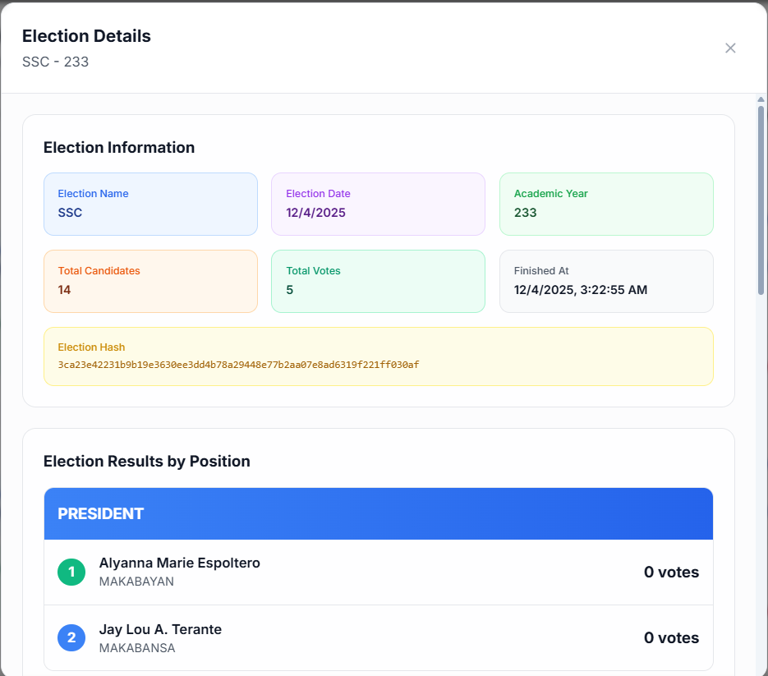**View Details (Election History):**

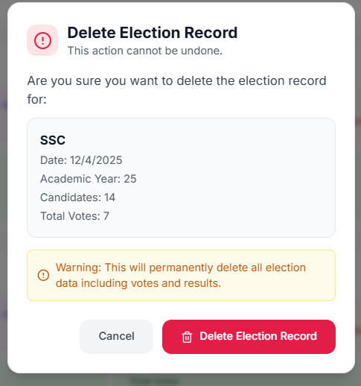**Delete Modal:**

**Super Admin Authentication Modal (**If Finish Election Button Pressed it will Authenticate the Super Admin First Before Finishing so that no accidental Finish Voting Poll will be happened**):**

**Finish Election Modal (**Finish Button is Clicked**):**

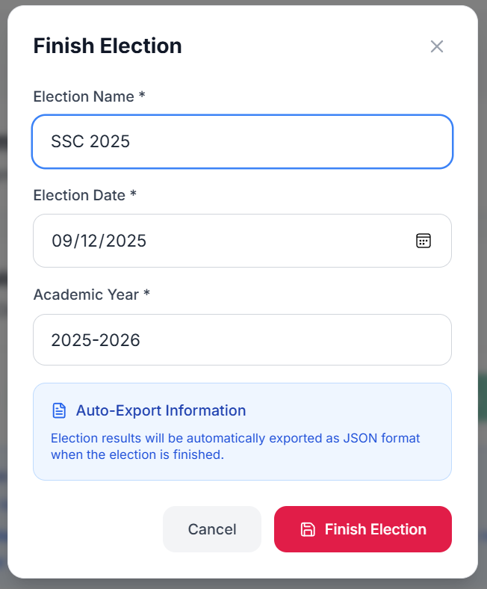

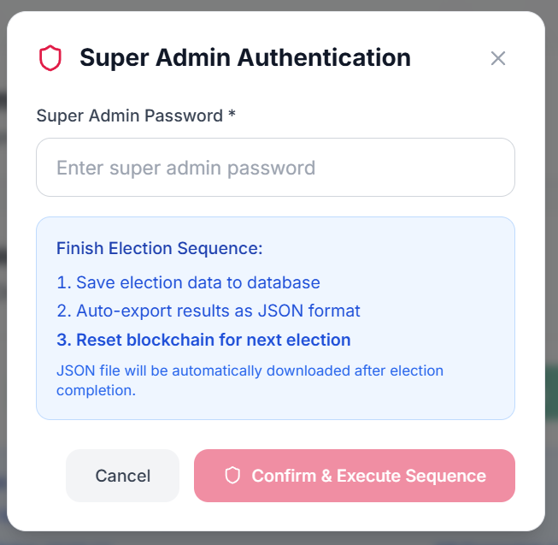

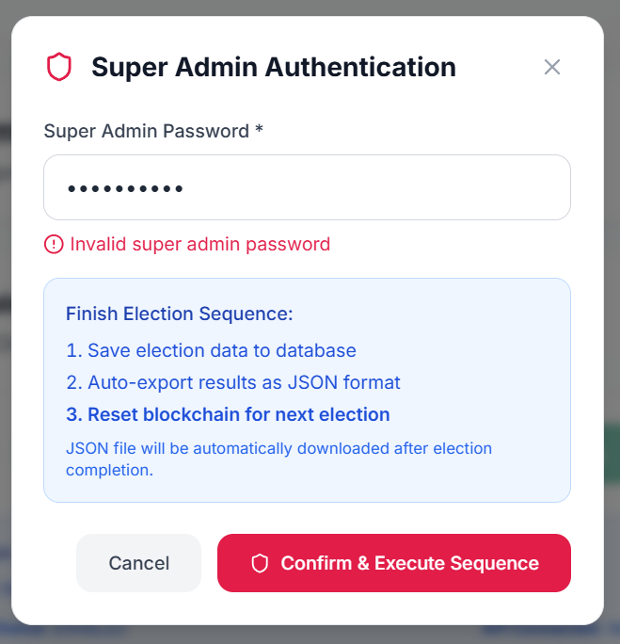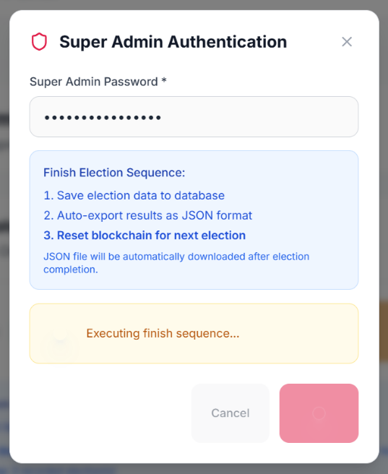

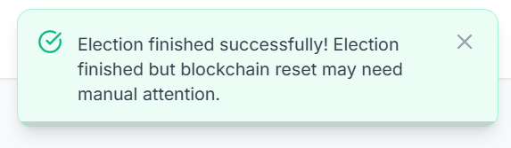

**Admin Management Dashboard:**

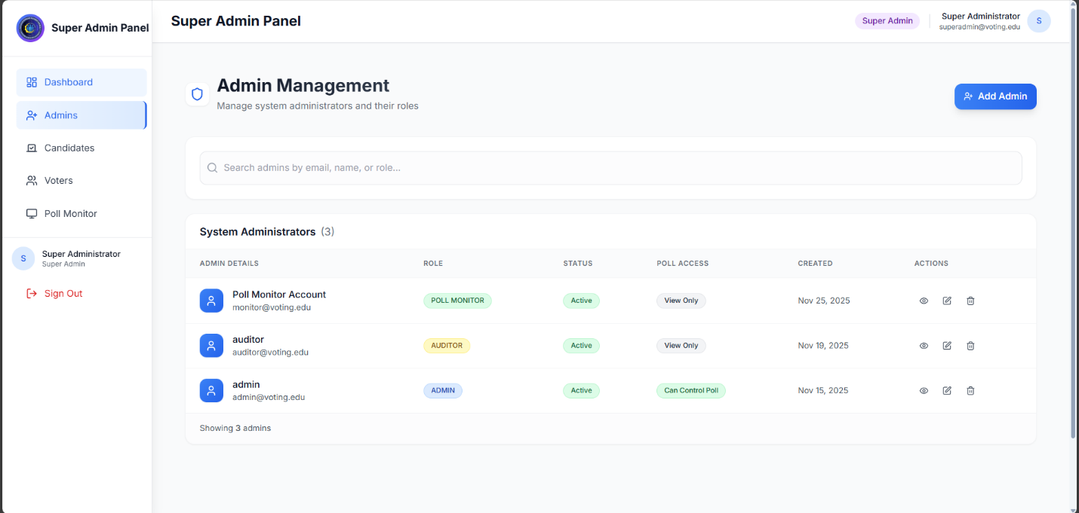

**Admin Details if Eye in Actions is click:**

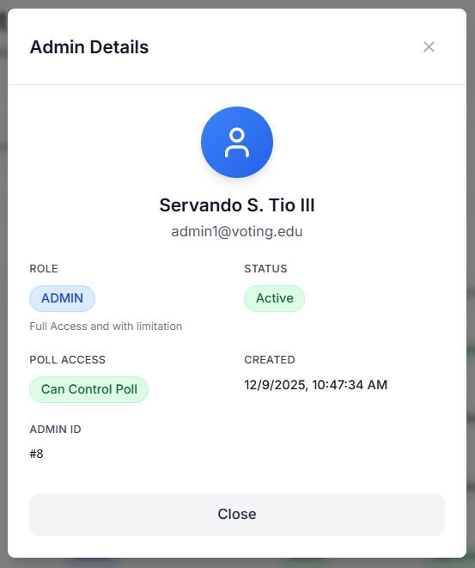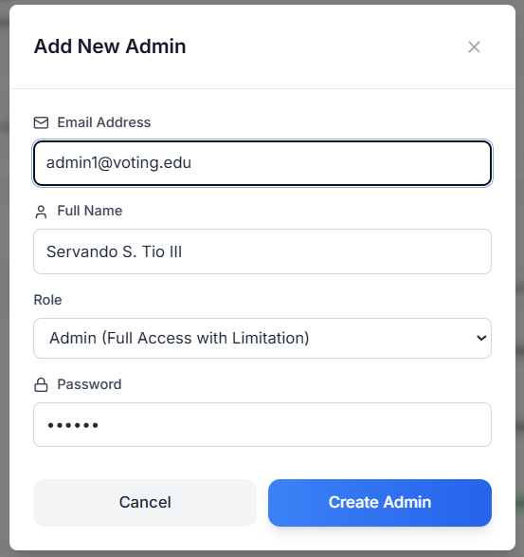**Add New Admin Modal (IF Add Admin Button is Pressed):**

**Delete Admin if Eye in Actions is click:**

**Admin Details if Eye in Actions is click:**

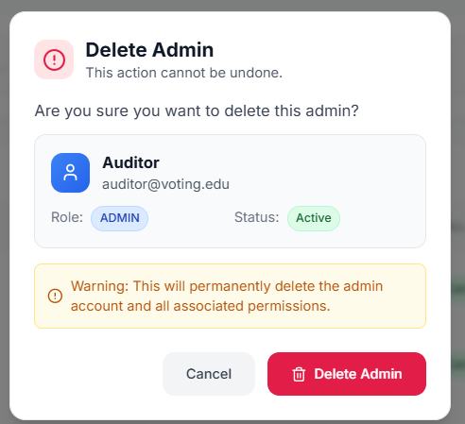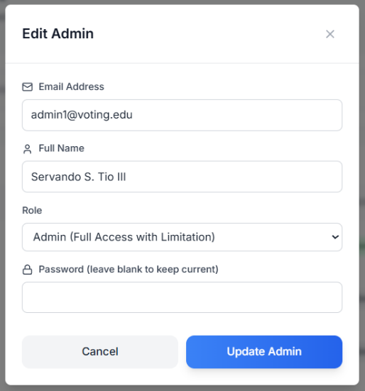

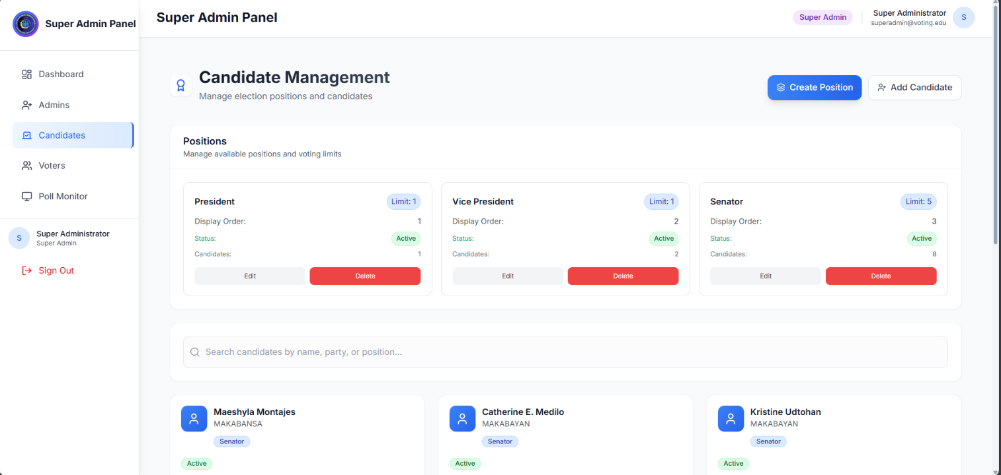**Candidate Management Dashboard:**

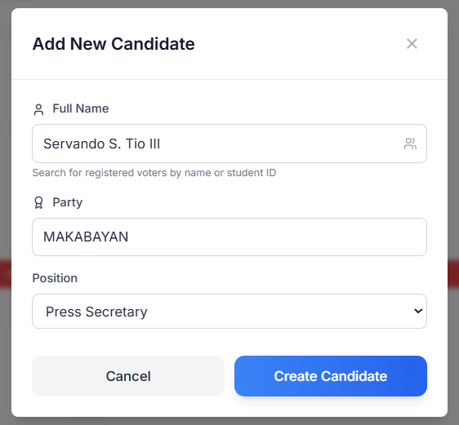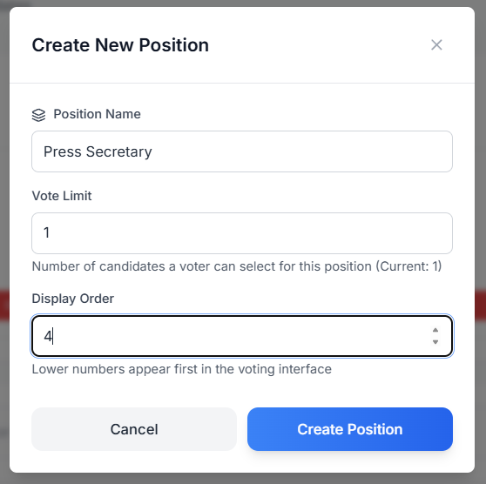

**Create New Position:**

**Add New Candidate:**

**Edit Position:**

**Edit Candidate:**

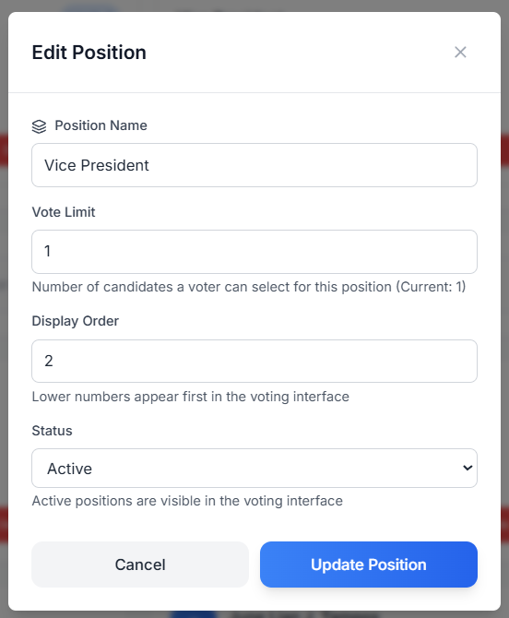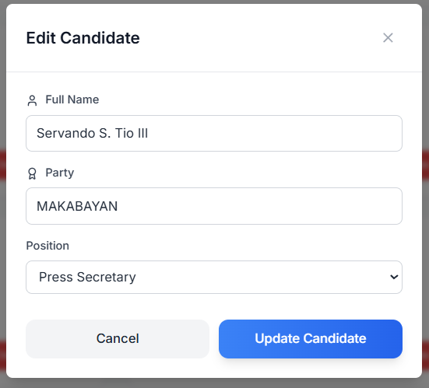

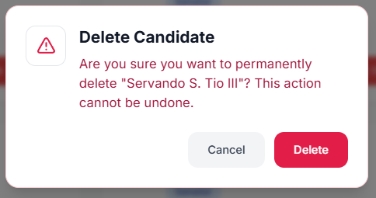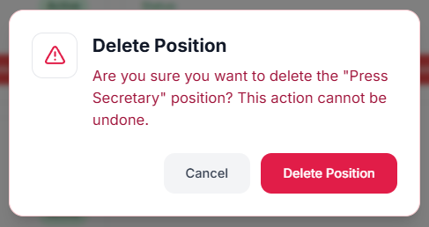

**Delete Candidate:**

**Delete Position:**

**Voter Management Dashboard:**

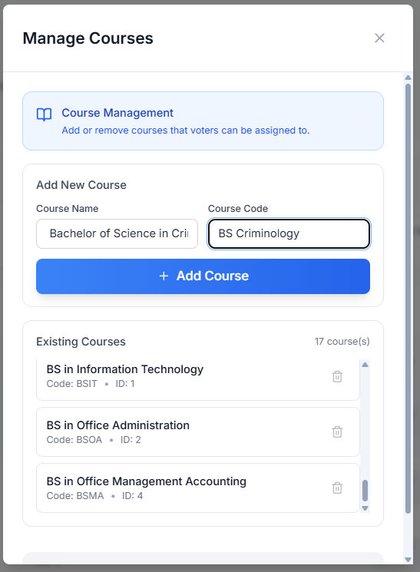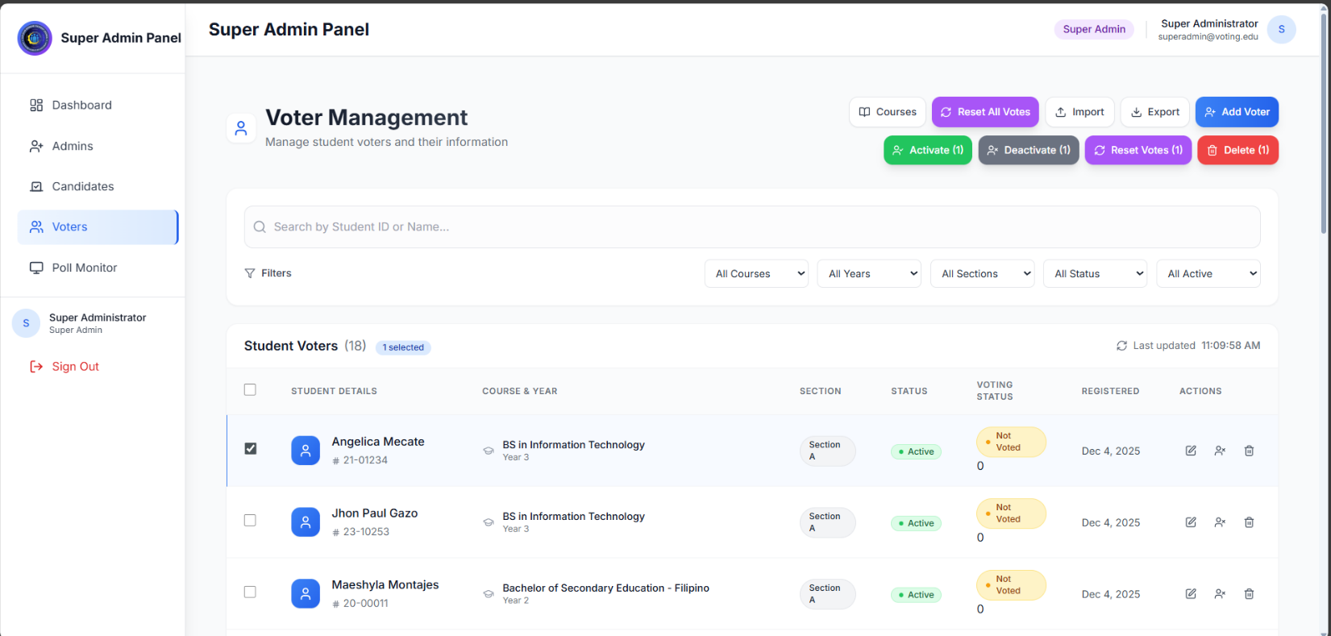

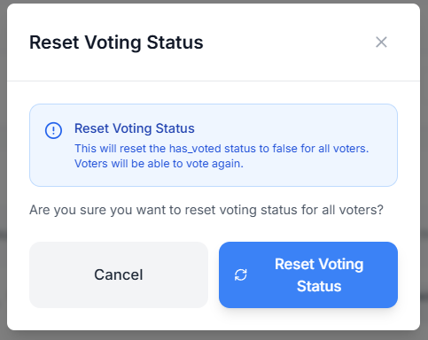

**Reset Voting Status Modal (Reset All Votes Button):**

**Manage Courses Modal (Courses Button):**

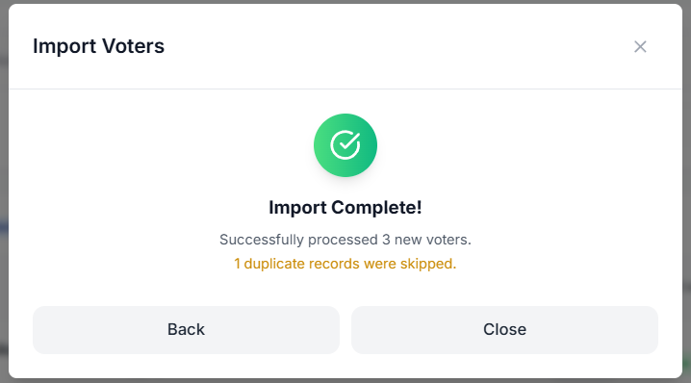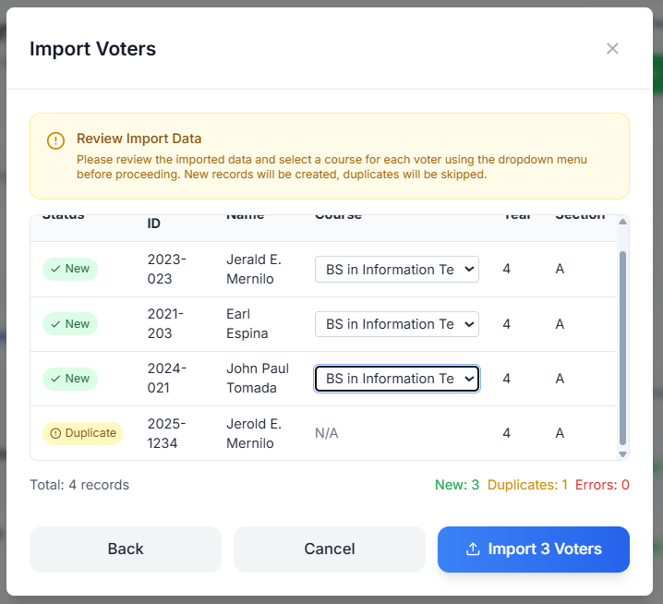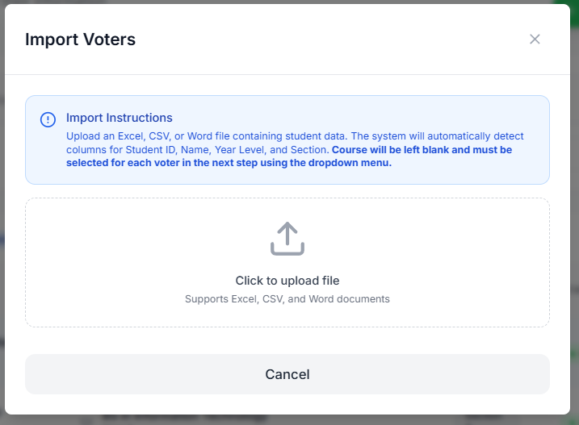

**Import Voters Modal (Import Button):**

**Export Voters Data Modal (Export Button):**

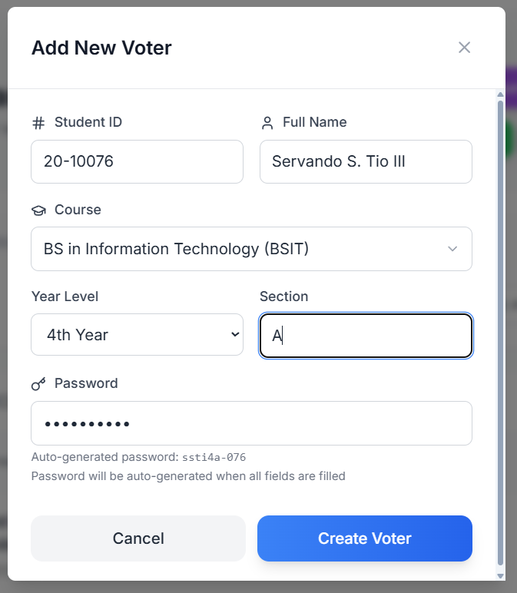

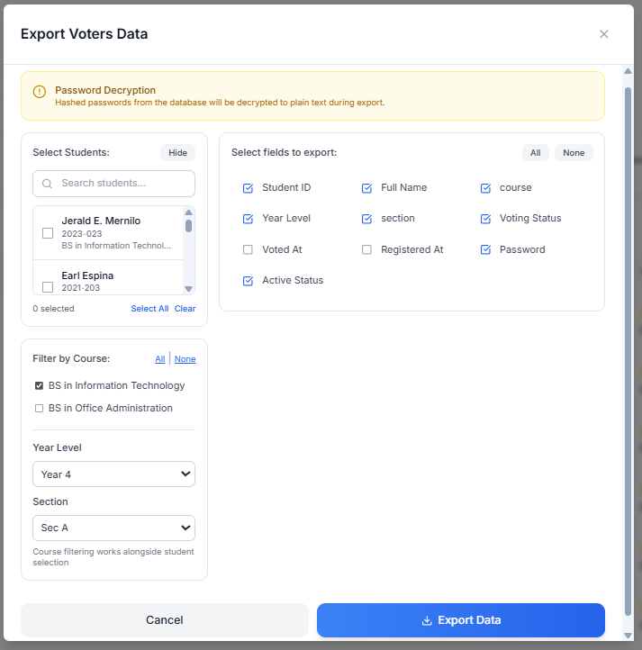

**Export Voters Data Modal (Export Button):**

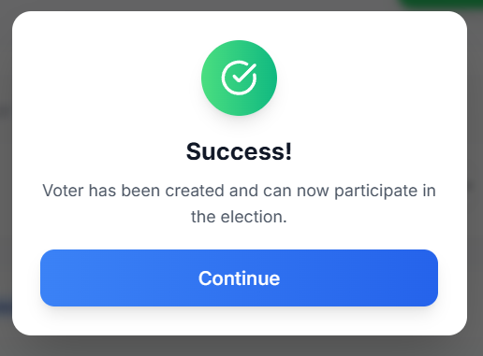

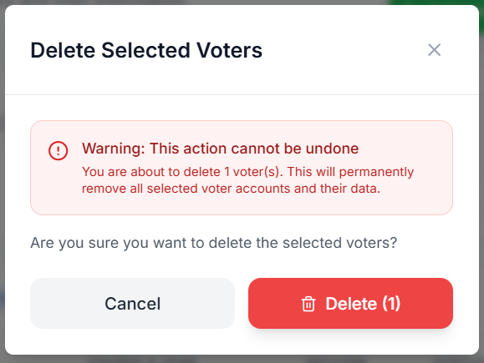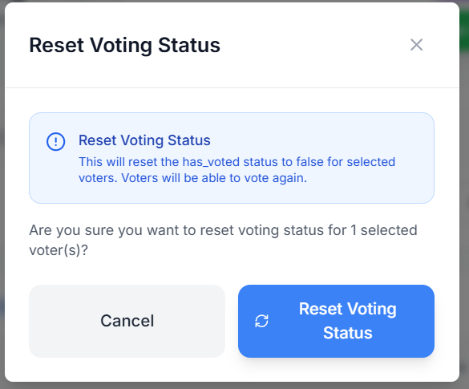 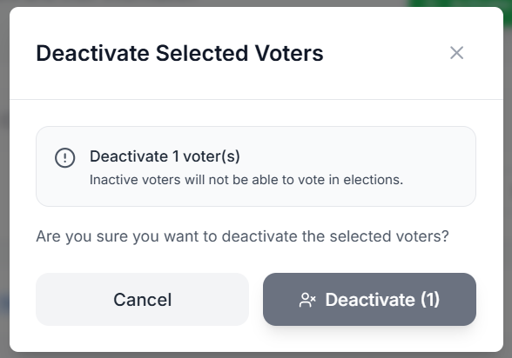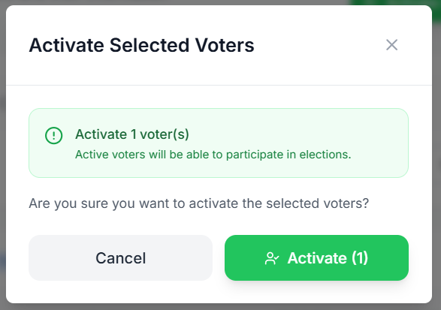

**Delete Selected Voters Modal (Reset Votes Button): Button):**

**Reset Voting Status Modal (Reset Votes Button): Button):**

**Deactivate Selected Voters Modal (Deactivate Button):**

**Activate Selected Voters Modal (Active Button):**

**Poll Monitor Dashboard:**

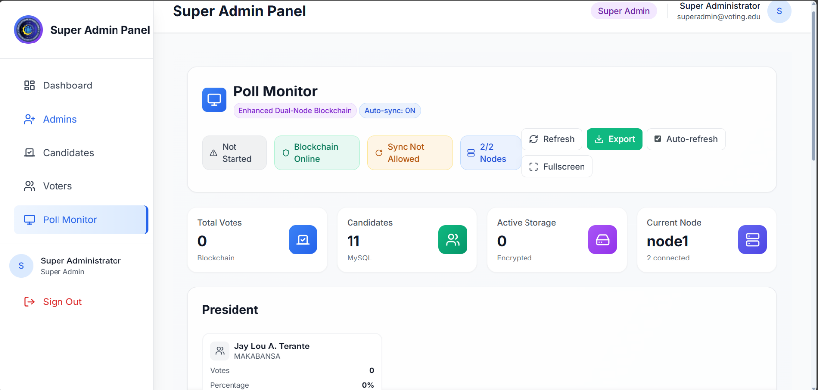

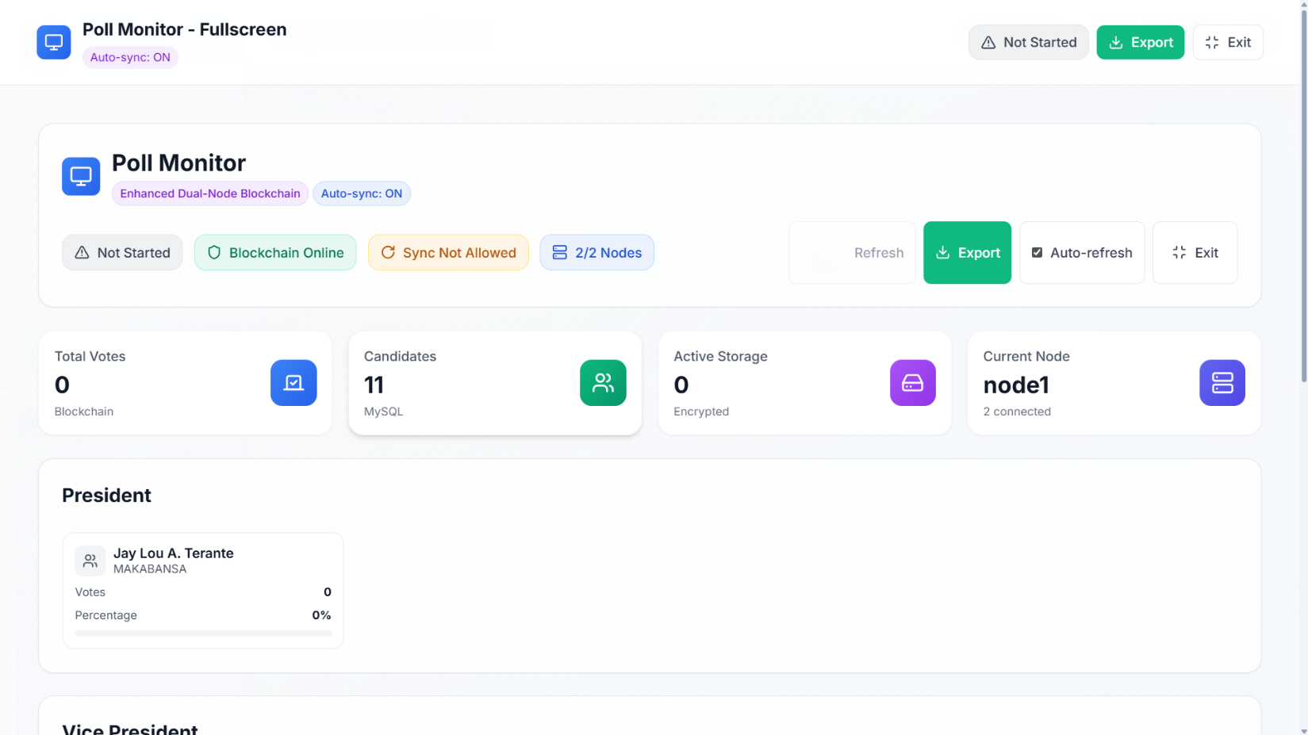

**Poll Monitor Dashboard (FullScreen):**

**Student_voting_system database:**

